Introduction

Ludiquarium (ludicrous + aquarium), **ACTION** game derived from Insaniquarium. The game has been changed in aspect of fish roles and some appearance of fish. (To be sincere, all of fish are changed to someone we already known)

This game consists of 4 tanks like Insaniquarium, contains Fish and Aliens like original, but the goal is to take care of Special Fish until it fully grown up and not eaten by Aliens

We hope you could enjoy mouse spamming like the old days. (And some frame drops like the old fashion game)

How to Play

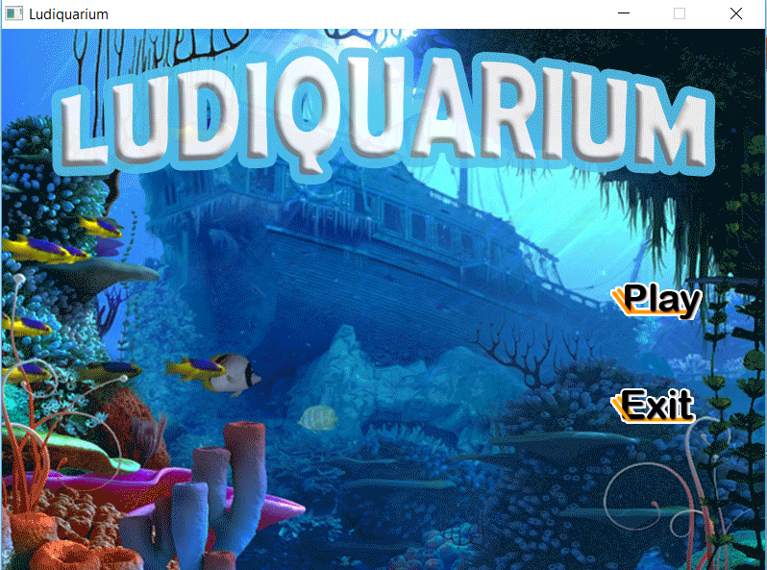This is our first page in the game, click on Play (anywhere which is not transparent) will take you to tank select screen. Or if you didn’t want to play anymore, click on Exit below Play button (This will prompt you for confirmation) or X at the top of screen (This will close program instantly)

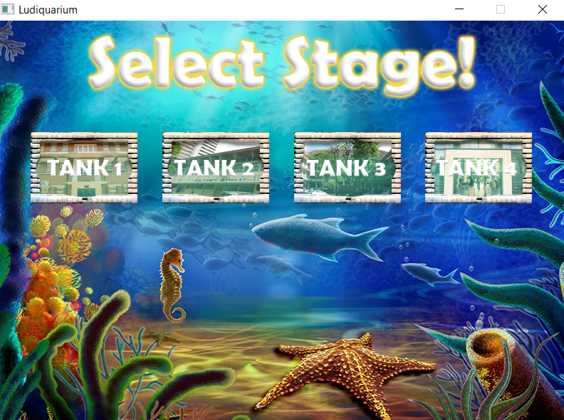

This is tank selection screen, click one time for highlight the tank and click again to go to that scene. Or if you are not sure about your decision, you can click the other tank to change your mind. (After main menu, closing game can be done by click X on the Title Bar)

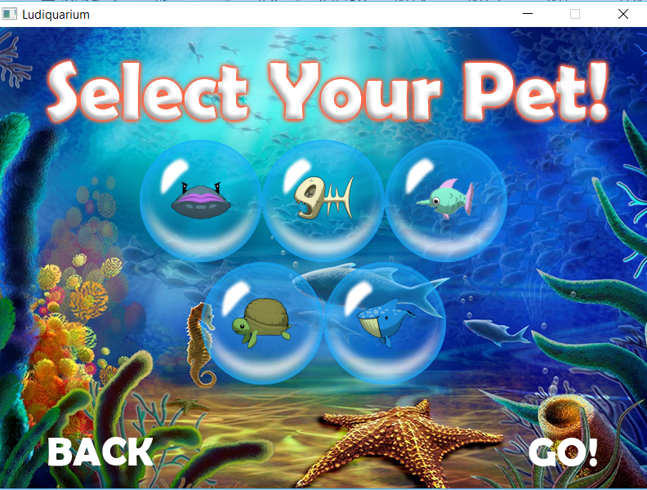This is pet selection screen. All pets will be unlocked at the first time you play.

Pet Description (From Left to Right, Top to Bottom)

Niko: Craft Pearl, which value for 350 coins. But it crafts slowly.

Vert: Act Like Lv.2 Guppy, craft golden coin.

Itchy: Help you in fighting with aliens.

Seymour: Make coin drop slower

Wadsworth: Keep Guppy in safe place when aliens came (But can make you lose the game for don’t have any fish in the tank)

You can select at most 3 pets (which means you can go by yourself without any companion) by clicking on desired pet and click again for deselecting it. After finished selecting, click GO! To play the game or click BACK if you think the tank (level) you selected before is not what you want.

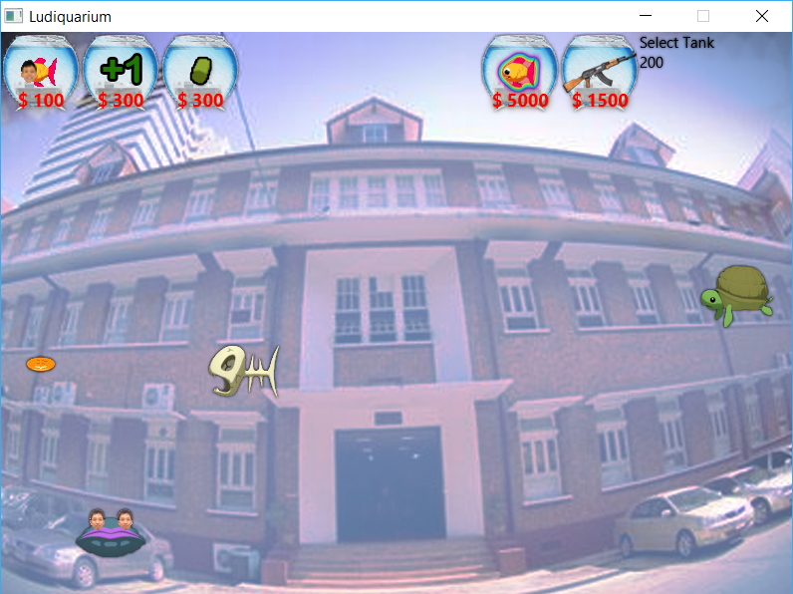

This is our tank screen. Top sections which contain bowls are item buying section, where you can buy the fish to your tank or upgrades to make your game much easier. Items are derived in many tanks. However, there are 4 items which sell in every tank.

* Max Food Upgrade (Item with +1 sign, $300): upgrade number of maximum food which can be in the same tank (Maximum: 9)
* Food Quality Upgrade (Right-hand side of Max Food Upgrade, $300): Upgrade food quality, which make fish grow faster
* Special Fish (Guppy with rainbow glowing, varied by tank level): Ultimate fish that you must raise it until fully grown. However, it doesn’t give you anything like other fish.
* Gun Upgrade (Item with gun icon, $1500): Upgrade attack damage when you clicked on some alien (However, some alien doesn’t affect by this upgrade)

About the other fishes, you should discover some of the tips by yourself. But I could `tell you that in this game, fish can strike back too! However, fish are ludicrous enough to make a fuss.



After raised special fish, you should see this screen. Or if you lose the game (don’t have any fish in the tank at some point of time), you will see something like below screen capture.



Good luck, have fun on your journey!